**DJANGO MANUAL**

**TABLE OF CONTENTS**

1. What Is Django
2. What Is Web Framework
3. Backend Vs Frontend Framework
4. What Can You Build With Django
5. Model View Template (MVT)
6. Installation and Setup
7. Virtual Environment
8. Simple Diary Application or Video Application

**1. WHAT IS DJANGO**

Django is a python base web framework and a backend framework on the server side, which simply means we can use python to build websites.

Django is one of the top frameworks for python and makes the building of website super-fast.

It is more of a heavy framework because it uses ***Batteries Included*** approach i.e it have more packages, modules and libraries to uses and follow a good structure. You can also customize django the way you want to structure it as well.

Django uses the MVT design pattern, most people know of the Model View Controller (MVC), but django uses the Model View Template (MVT)

**2. WHAT IS WEB FRAMEWORK**

This is a collection of modules, packages and libraries designed to speed up development. You don’t have to use python to do a lot of things

**3. BACKEND VS FRONTEND FRAMEWORKS**

Backend (Server Side), we have the;

* Php and uses Laravel as framework
* Python and uses Flask, Cherry Pie, Web2py, Pyramid , Django(which we will be using)
* Nodejs uses Express

Frontend (Client Side) we have the;

* React
* Angular
* Vue

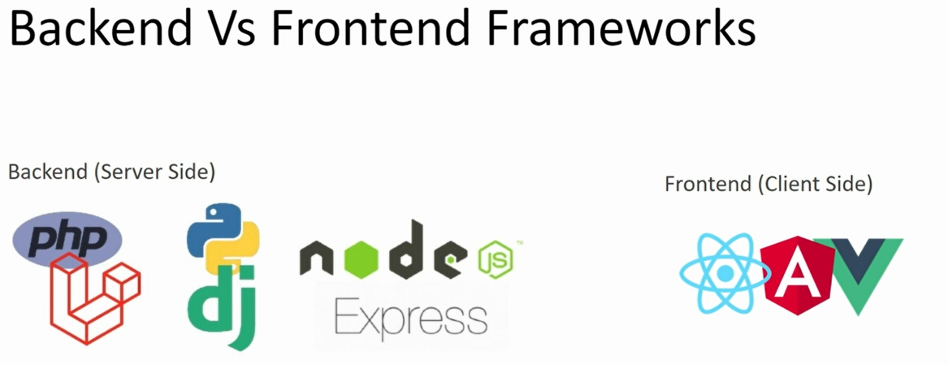

You can use either of the frontend with either of the backend i.e django + vue ; we just build an Api to connect them both.

This does not mean we need a frontend frameworks , django has its own template engine.

**4. WHAT CAN YOU BUILD WITH DJANGO**

You can build a lot using django;

* e-commerce website
* social network
* an API for mobile app

There are some commonly used website built with django

* pintrest
* spotify
* udemy
* dropbox
* instagram, they rely on django in the beginning, don’t really know how much they have customized it and the version they use
* Youtube, most articles show that Youtube was built with django. DYOR

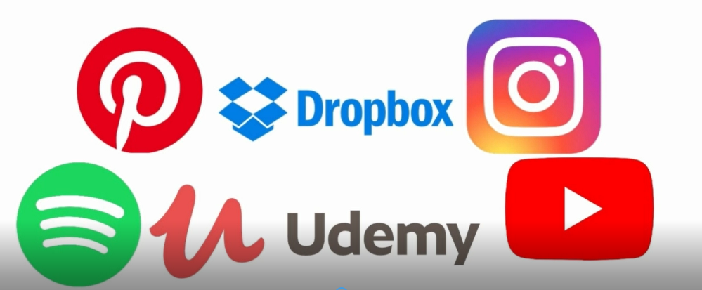

**5. MODEL VIEW TEMPLATE (MVT)**

Django follows the MVT structure unlike the Model View Control (MVC), django takes care of the controller aspect of things.

**M- Model**: This is the ***database access layer***, where you have your tables, built out in classes

**V- View**: This is ***business logic layer***, this controls how the client side and server side response.

**T- Template**: This is the ***presentation layer***, this is what the users see (client side)

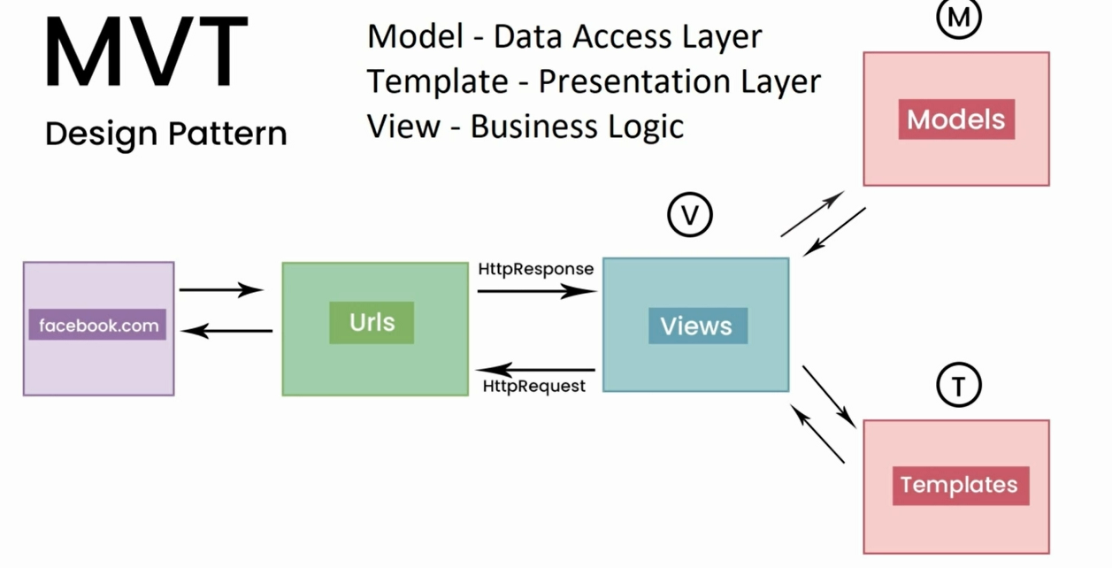

**6. INSTALLATION AND SETUP**

To start working with django, I believe you should have study python and have it install on your machine as well as code editors ; vscode, sublime, atom etc. But will recommend Vscode, it has a features of installing cool extensions;

**Extensions**

* Prettier
* Bracket Pair
* Pylance /python
* Django (Roberth solis)

**7. VIRTUAL ENVIRONMENT**

A virtual environment (venv) is a folder that contains all the libraries

and packages that you application depends on. These includes the python,

django package and any other package that you need for your project.

This helps us not to have conflict with other project.

**Note:** we can use django globally on our machine, but venv is more recommended.

Take for instance we have a project built with python 2.0 and then did an update to python 3.0 and start another new project. Now the project with python 2.0 will not work because of compatibility issue, due to the fact we did both project globally.

**Creating Virtual Environment**

They are several approach of doing this

1. Install virtual environment using : **pip install virtualenv 🡪 virtualenv (environment name you want) i.e “**virtualenv book”
2. Using: **python –m venv ./(environment name you want)**

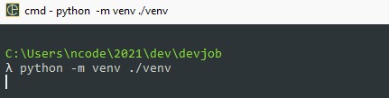We will be using the step two throughout the series; you are at liberty to use any.

The next step after creating an environment is to activate it and we can do that in two ways;

1. **Environment name\Scripts\activate**
2. **C:Environment name\Scripts\activate.bat**

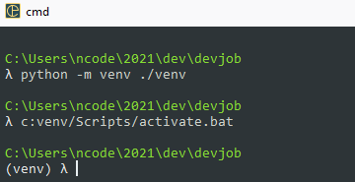To know if it is activated, the environment name will appear at the back of you c: i.e (venv)C:\...\...\...devjob

You can deactivate and go back to the global environment with

**Deactivate**

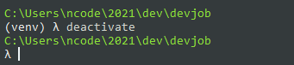

**8. STEPS TO START A PROJECT**

- after virtual environment is activated

- pip install Django (installing Django)

- Django-admin startproject core .

- python manage.py startapp (app name)

- initialize git and add a ignore file ( git init , touch .gitignore)

- go to <https://gitignore.io/> in your browser and enter Django and copy and paste the file in the gitignore

- go to settings -> import os , register installed app, register templates